April 19, 2023 Minutes of Monthly General Meeting  Chair: Margo Murley Recorder: Elfi Berndl  In Person Meeting, Burr House 7 pm | 
E&O
In Attendance  Elfi Berndl Janet Porter Kathy Lakatos Liz Kennedy Margo Murley Michelle Zikovitz Olga Draznin Sandra MacKenzie Sheila Hamilton Sophie & Karen Tepperman Susan Schillemore Val Firmin |  |  | Regrets  Adriana P.B. Allison Durno Amanda Ring Amna Nawab Andre Beaumont Anthony Savanorato Athena Antiochos Barbara Anderson Christina Henninger Doris Moneweg Eleanor Mayne Gail Gibson Julie Liut Kara Kivioja Leah Stone Linda Ewing Mary Davie Mary Dunn Nancy Martin Peggy Spurgeon Saima Malik Shiva Moghaddasi Teresa Clarke |  | Honorary Members  Joan Colnett  Jo-Ann Rootham  Kate Deuitch
Business - Agenda Items Information / Follow Up
1 | Welcome & Members Update |  |  | - Liz Kennedy now joins Amanda Ring as being an approved beanie crocheter for the Magic Yarn Project  - A granddaughter arrived for Michelle Zikovitz  - Nancy McGuffin Price, founding guild member, died at 95 on April 12, 2023 (see tribute & pics below)
2 | Upcoming Classes / Guild Get Togethers |  |  | - Thursday afternoons drop-in  - Wednesday evening drop-ins (except for 3rd Wednesday of the month which is our Monthly Meeting September to June)  - Tuesday weavers
3 | Update on recent classes |  |  | - Thanks to Sheila & Allison, 3 members attended the Introduction to Weaving on the Rigid Heddle and the $150 was donated to the Guild
4 | Upcoming Events to participate in |  |  | - Richmond Hill Cultural Summit, Wed. Apr. 26, 6-9pm – Sheila, Margo & Elfi  - Guild Spring Sale, May 6-7  - Heritage Summit Planning Meeting on Monday May 8th at 1:00 PM @ Richmond Hill Centre for the Performing Arts, Plaza Suite.  - Richmond Hill Doors Open, Sat. May 13, 10am to 4pm – Gail & Kathy  - Heritage Summit celebrating Richmond Hill’s 150th Sun. Sept 10
5 | Spring Guild Sale |  |  | - postcards distributed, online distribution of cards happening, 12 members selling items, FB page editors added – Janet, Michelle  - volunteers needed to help clean up on Monday May 8
6 | Classes |  |  | - Drop Spindle - June?  - Classes to be offered to members first, then open to beyond  - notice of upcoming classes on FB & website  - Kathy will arrange for classes if there is something you are interested in  - We need instructors from within the Guild or others willing to teach – anyone willing to work on this?
7 | Upcoming Presentations, Seminars and Classes |  |  | - February to May Ontario Handweavers & Spinners: Webinar series: Cotton  - May 13 Peterborough Fibre Arts Festival and Sale  - May 17 - Monthly Meeting In Person - All About Spinning  - June 2-4 Ontario Handspinning Seminar:, Burlington  - June 10 Kawartha Fibre Fest - Fenelon Falls  - June 24 Muskoka Fibre Fest - Bracebridge
Presentation / Hands On Activity
Thanks to Val, we will be making felted soaps for our 2023 Spring Guild Sale
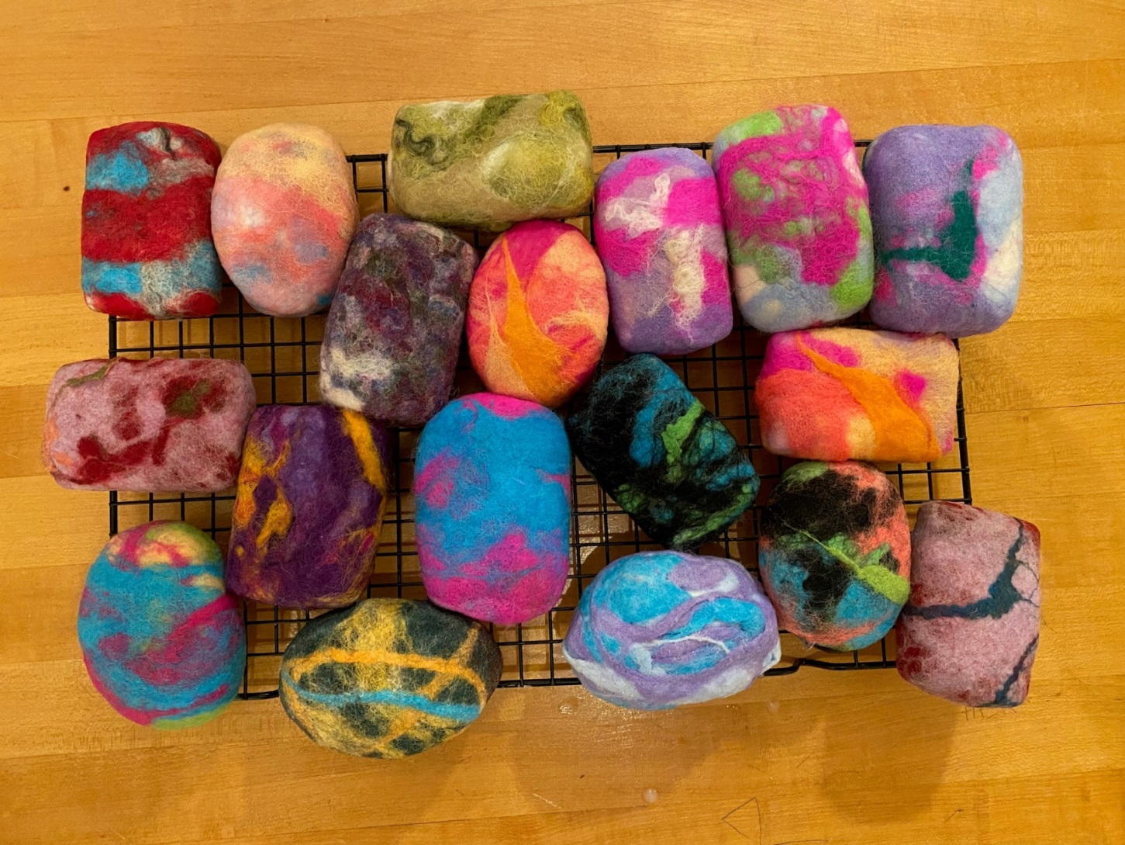
Show & Share 8:30 – 9:00
 | Show & Share | Kathy – 2 scarves, shoelaces  Sheila – 2 gnomes, Amber’s sock yarn scarf finished for her family, samples of Krokbradg weaving from recent class  Olga – crocheted purse  Sophie & Karen – snow dyed cotton cloths from recent workshop

Tribute to Nancy McGuffin Price April 12, 2023  To all the friends of the Burr House Spinners & Weavers Guild, the Richmond Hill Historical Society and the Hill Potters’ Guild ... We are sad to announce that one of our Founding Members, Nancy McGuffin Price, has passed away at age 95. Nancy was on the Building Committee which brought the Guild Hall to its current location and celebrated our Official Opening on October 23, 1982. She then was involved in the research and publication of Spectrum: Dye Plants of Ontario which was first published in 1986. Nancy was an active member who in recent years became an Honorary Member who visited from time to time. She inspired many who knew her as a friend and a talented fibre artist. Nancy told us that she remembers her days with the Guild as happy times. She will be missed. |  | 
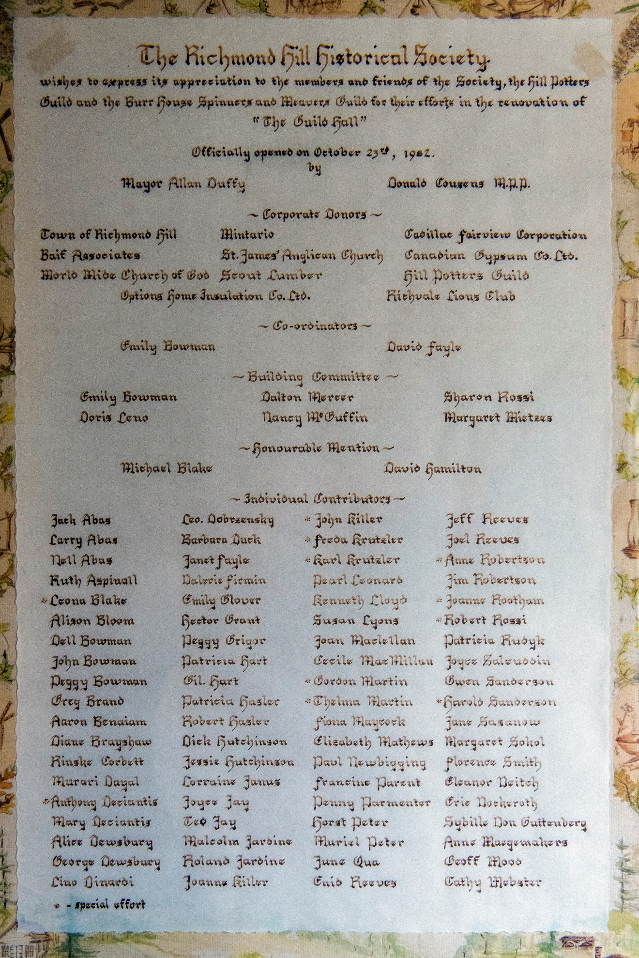
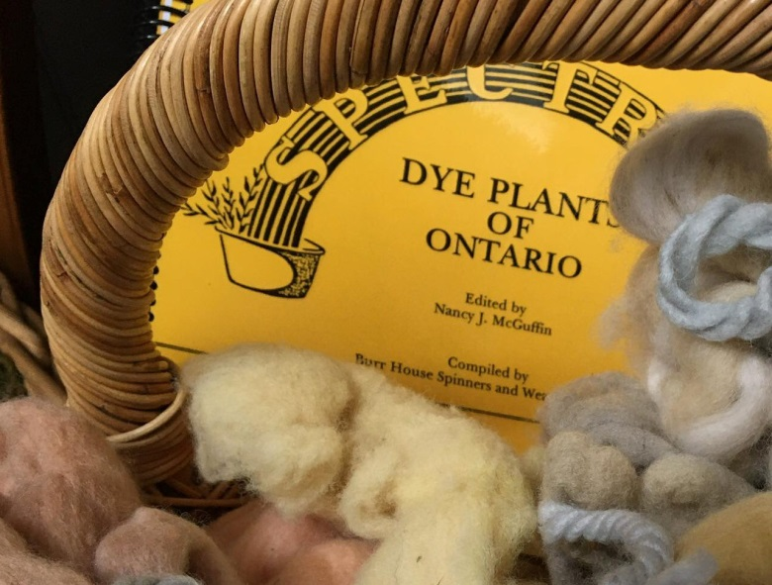 | 