June 7, 2022 Minutes of EXECUTIVE COUNCIL Meeting
Chair: Margo Recorder: Elfi
https://us04web.zoom.us/j/9027180459 Zoom Admin: Amber

In Attendance Executive Council Officers  President Margo Murley  Secretary Elfi Berndl  Past Pres. Michelle Zikovitz  Present for only parts:  2nd Pres / Vice President Athena Antiochos – end part  Treasurer Amber Bole – beginning  Membership Peggy Spurgeon - middle |  |  | General Membership Present:  Sheila H. Kara K., Shiva M. Deborah O.S.  Copies of Minutes to:  BHS&WG General Membership  Executive Council, Members Info Binder  NEXT Executive Council Meeting Date:  Not determined at this time  Tuesday ?, 2022 7pm
 | Agenda Item | Information / Concern / Decision / Action / Follow Up
1 | Welcome
2 | Public Relations | - One of our Constitutional Aims & Objectives (1995) is “To promote and awaken public interest in appreciation of handweaving, spinning and dyeing and related fibre arts.”  - Now with the reopening of activities post-Covid19, we need to plan which local events we will participate in  - Events can include manning a booth, displaying work produced, demonstrating a skill, having make & take activities, welcoming the public into our Guild Hall.  - We need to re-establish our presence in Richmond Hill moving forward. Letting the public know that our Guild is alive & well.  - Future members may learn about us by seeing us in action.  - In order for Members to plan on volunteering for events, a current list of events needs to be produced. People want to participate, but don’t know how or when early enough to put it in their own planning calendar.  - This Events List could be added to the Membership Renewal Letter sent out in August.  - An Events (Exhibition/Display) Convenor is a vacant position which could oversee this.
3 | Organization of the Guild | - It is time to review the Organizational Structure of the Guild and to create a written Framework document which outlines  - what is in place already  - who is responsible for what  - what areas need review, expansion, are duplicated etc.  - what opportunities are there for Members to volunteer within the Guild  - Currently there are roles that would benefit the Guild if they were filled:  - Monthly Meeting Program Coordinator  - Historian / Archivist  - Events Coordinator  - Directors (3) once we achieve ONCA compliance (in 2023 hopefully)  - A Brainstorming Session will take place Thursday June 16, 2022 @ 2 pm in the Tea Room  - The In Person session will to try to capture the Organization Structure of our Guild as it is now and how we would like it moving forward.  - Margo, Elfi, Deborah, Sheila Shiva Athena
4 | Budget | - .postponed because Amber not available  - As budget information needs to be sent out to the Membership for review prior to our September AGM, another meeting may need to be called.
5 | Post (?) Covid  P.C. - Moving Forward | - Moving forward, The Executive Council, will make decisions regarding any procedural changes that need to be made due to Covid and related health issues.  - Any member having concerns about Covid Protocols that should be reviewed should contact Margo (President)  - As the Wednesday Night Drop Ins are being started up again, it was asked if the 12 member limit and the need to preregister through Google Docs could be lifted for the ONE weekly time slot of 6pm to 9 pm on Wednesdays.  - Agreement could not be reached so the membership will be asked to vote on this.  - How Monthly Meetings will be held as of October 2022 was discussed.  - The membership will be polled if they are OK with continuing having our Monthly Meetings on Zoom for a year.  - The possibility of having a Hybrid Monthly Meeting Structure – namely In Person at the Guild as well as via Zoom was discussed but involves money and technology that we don’t have. Someone would have to research and bring back a viable proposal.
6 | 40th Anniversary Celebration | - We will have a 40th Anniversary Celebration this Fall  - A tentative date of Saturday October 15, 2022 is set (to be confirmed by the end of July)  - It would be nice to combine the event with Sheep to Shawl and make it during Culture Days if possible  - At a minimum, the Celebration will consist of an Open House from 1 to 3 pm with Presentations at 2 pm.  - Anyone wishing to help out on the Committee, chat with Elfi.  - Anyone wishing to approach the Potters Guild to join in our Celebration are asked to take this on. The more the merrier. Just let the 40th Anniversary Celebration Committee know (tell Elfi)
 | June 15, 2022 Monthly Meeting | - A reminder that the June meeting is an In Person Event held at the Guild Hall.  - We have reserved the Guild Hall, the Burr House Building and hope to meet and mingle in the Parking Lot if the weather is nice.  - The meeting starts at 7 pm.  - Bring a lawn chair, a beverage of your choice and some dessert (finger food size that requires no plates or cutlery) if you wish to share for our Dessert Table.

From the Guild Hall Archives ...
Photographic Support Materials for the Burr House Spinners and Weavers Town of Richmond Hill Cultural Grant Application in 2017
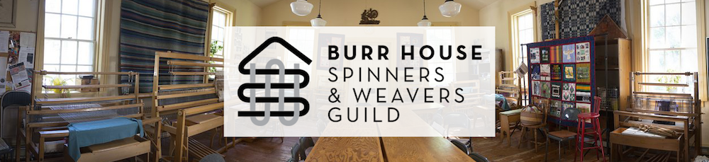
www.BurrHouseFiberArts.com
BurrHouseW@gmail.com
2017 is the 40th Year that this organization has been in existence at The Burr House, 530 Carrville Rd.
Some impressive activities have taken place the most notable of which are recorded below.
- In the 80’s we have tested and recorded the properties of many plants to find the optimal dyes that are natural. We have many books of these test results in our library.
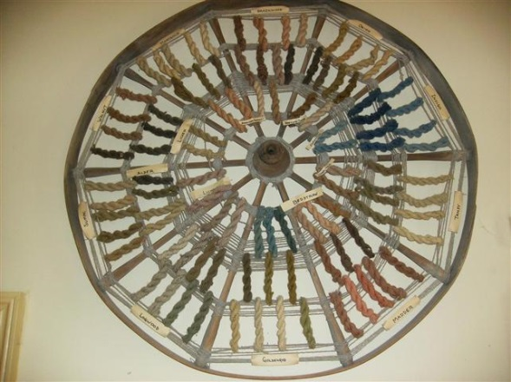
- On our Guild Hall wall, we still have samples of wool that has been dyed using the knowledge of this “Spectrum” that are not faded!
- This work resulted in a published book complete with hand drawn illustrations. The publication was so successful a second edition was published and is still being sold and used in all textile colleges in Ontario and we continue to send the books all over Canada.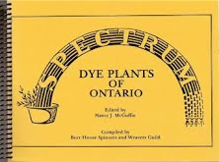
- In the late 80s detailed maps were made of the land use around Richmond Hill by members driving round and sketching. These plans were combined into a Tapestry complimented by embroidered heritage buildings acting as the border. This work of art is now in the permanent collection on display at The Central library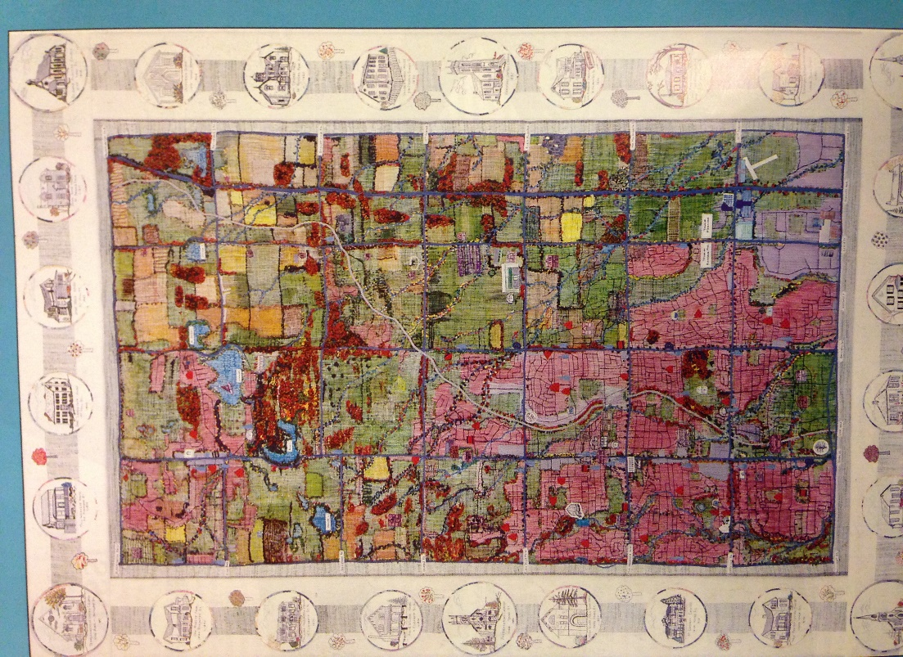

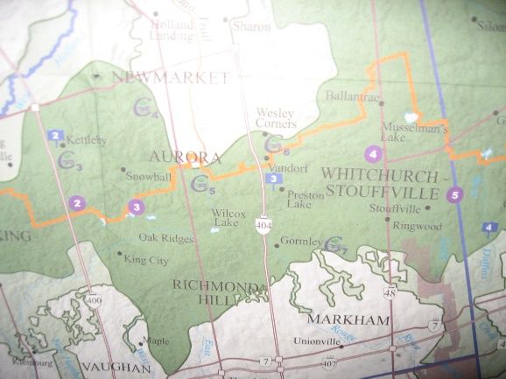
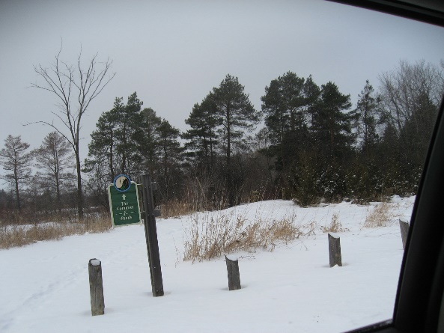
- The Quilt of Possibilities was made celebrating Ontario’s Green belt. We took our inspiration from the Phyllis Rawlinson Park to celebrate the Oak Ridges Moraine as depicted in our Tapestry Square which was subsequently added to the completed Quilt. We were invited to Queens Park to see its unveiling in the Speakers Formal rooms. 