May 18, 2022 Minutes of Monthly Meeting
Chair: Margo Recorder: Elfi
https://us04web.zoom.us/j/9027180459 Zoom Admin: Amber

In Attendance Amber B. Amanda R. Andrea D.M. Athena A. Deborah O’S. Eleanor M. Elfi B. Gail G. Kara K. Kathy L. Kathleen R. Leah S. Linda C. Liz K. Margo M. Mary Da. Mary Du. Megan M.C. Olga D. Peggy S.  Saima M. Sheila H. Sophie T. Susan S. |  |  | Regrets  Adriana P.B. Allison D. Andre B. Anthony S. Barbara A. Christina H. Helen O’S. Homeira N. Janet P. Julie L. Linda E. Michelle Z. Nancy M. Shiva M. Teresa C. Val F. | Notification only  Joan C.  Jo-Ann R.  Kate D. Nancy P.
 | Business Portion of Meeting 7:00 pm
 | Agenda Item | Information / Decision / Further Action by
1 | Welcome | New Members: Spring 2022 Andre B., Linda C., Andrea D.M., Homeira N., Adriana P.B., Leah S.  Fall 2021: Teresa C., Allison D., Saima M., Anthony S.
2 | Community Outreach opportunities | - Ukrainian Refugee “Coffee & Craft”Drop In in our Burr House Tea? Richmond Hill Good Neighbours & Office of Mayor David West are looking of ways to help the 100 Ukranian Refugees settle in, feel welcomed and practice speaking English. This will take a few months to get started and our offer would be in addition to many other supports being offered by local organizations. To run any program on our premises would require a Guild members to be present each time. Elfi is willing to be present if we do this twice a month. Consider our commitment for 6 months and then review. Contact Elfi if this interests you.  - Culture Days this Fall – we will participate with a set up at the Main Public Library as we have done in the past. Consider volunteering to man a Guild Table with some hands on activities such as weaving on a warped Rigid Heddle Loom. Possibly also a Sheep to Shawl demo. Demonstrations such as small loom weaving and spinning always a hit. Display of some of the items we make as well as info on the Guild for potential members. Consider volunteering on this day.  - Knitting Teacher Wanted for Knitting group for seniors programme @ Oak Ridges Community Centre. Contact Margo if interested.  - Resumption of our weekly evening Drop In Sessions – will wait till there is greater demand?  - 40th Anniversary Open House in October – to highlight our role in the community, our members current & past. Possibly have a walk through while members weave, spin, felt or sew – whatever they choose to do – in the Guild Hall. Combine with a Sheep to Shawl? November Winter Sale? Contact Elfi if you are interested in being part of a 40th Celebration Committee.  - Sheep to Shawl Team About 6 members needed to form a S2S Team this Fall. Contact Margo if you are interested in one or more of these roles: Pre-Event washing, deciding on weave, dressing the loom Day of Event: set up, carding, spinning, weaving the shawl.  - Informing Community of our Activities: We should try to put future event dates out there earlier, need a leaflet about our Guild to distribute at local events in the next 6 months, possibly on our sale postcards for Winter 2022 Sale? Any event from now till end of year could be tagged as part of our 40th celebration
3 | Website – new page for members Only | Members Face to Face To help us to get to know each other better, we will create a new page in the Guild Member Area which is private and password protected. The majority present at the meeting voted that this is worthwhile. We will ask Janet to create this page and upload the content. The content will include a photo of the member as well as a “blurb” about themselves. The intent is for us to get to know each other and our experience and interests. Elfi will send out a sample write up and assist Janet in whatever way she requires. Only current members will be included on the Members Face to Face page. If a member does not wish to submit their picture or a blurb, only their name will be included.
4 | New Horizons for Seniors Program Grant 2023 – suggested by MP Majid Mowhari | MP Majid Jowhari suggested that our Guild apply for a New Horizons for Seniors Program Grant for 2023 - for a program that would benefit our community in Richmond Hill and Seniors  - we have till November 2022 to decide if we wish to apply  - past NHGrants were a lot of work, need to have people work on it and it must benefit the Guild – such as creating a financially viable Hybrid Meeting / Program delivery system which would bring WiFi into our Guild Hall or the Burr House.  - The $25,000 needs to spent within a year.  - Ask Elfi for info sent to her about NHSP Grant.  - Margo to set brainstorming date for more discussion
5 | Workshops & Classes | - 1) New Weavers & Intro to Rigid Heddle Weaving, 2) Basic Weaving on a 4 Shaft Loom, 3) Advanced Beginner 4 Shaft Weaving Course - developed and will be offered by Kathy & Sheila  - Introduction to Spinning with a Drop Spindle to be offered in September, contact Margo if you are interested  - Craft Class: Make a Bead Tree will be offered by Liz & Elfi in next 2 months, contact Elfi if interested
6 | Summer in the Guild Hall | - Remember to close doors and shut off fans in the summer.  - A request has been made to the City for ways to make the guild hall cooler in the summer.
7 | June 15th In Person Monthly Meeting | Our June 15th Meeting will be In Person – in the parking lot, on the porch, in the Guild Hall, in the Tea Room Start time: 7 pm but feel free to come a bit earlier  - bring Lawn Chairs, finger food, stuff to show
13 | Spring Sale Report | Spring 2022 – made $900+ profit with 12 members participating  Fall 2022 –November 5 & 6, 2022  Spring 2023 – requesting 1st weekend in May - May 6 & 7, 2023  Fall 2023 – requesting November 4 & 5, 2023  - We’d like more people to submit items for sale.  - Consider volunteering on the Sales Committee  Tea Towels Team headed by Kathy – to weave tea towels to be sold at sales with profits going to the Guild. Guild to pay for warp, Guild Members to weave and donate towel woven
14 | Voting on Issues / Motions | How to vote & tally on issues on Zoom is not known by all. Whoever is interested can develop a procedure and ask for it to be tried at a meeting with an issue that requires a vote. It is not yet clear which items require a vote and what % is needed to pass motions. This will become clearer as we move towards ONCA compliance.
14 | Group Weaving Projects | We need realistic time frames for those participating in Group Projects.  Suggestions for how to make timing less of an issue: use shorter warps. cut off woven items mid-way, ask for help from fellow members, ask for transportation or company in the Guild Hall if solo, ask others to go before you in line, offer your spot to others in the Guild
Program @ 7:30 pm Introduced by Programming Co-Coordinator - Megan
Presenter: Ron Walker Retired Professor of Computer Engineering Technology – Gripper / Jacquard Looms
- As the son of a “Loom Fixer”, Ron has fond memories of the 1906 Gripper Axeminster loom that his father, Mitch Walker, bought from his employer, Briton Carpets. The loom was moved to Havelock Ontario and became the basis of Walker’s Weaving Shop.
- Axminster Heritage Centre – Gripper Loom https://www.youtube.com/watch?v=0uRfNNzpHhs

Show & Share: 8:30 pm
- Kathy - Fishy Tea Towels – 8 shaft pattern, based on Summer/Winter 2/8 cotton, boucle
- Elfi – fused glass non-weaving weaving coaster
- Margo – coaster, book mark - woven on a small wooden loom – using a weaving needle
- Eleanor – bibs
- Liz –Becky’s Knit & Yarn shop in Nova Scotia, dyes to match colours in nature, runs a mobile Yarn-Mobile, cards will be left in the Guild Hall https://beckysknitandyarn.ca/

Upcoming Events, Meeting Dates & Programs:
- June Intro to Weaving Class (Rigid Heddle Looms) Date TBA
- June Crafting Class: Make a Bead Tree Date TBA
- Wed June 15 2022 6:30 pm Monthly Meeting ~ Social In Person Get Together – parking lot, porch of Burr House, Guild Hall & Tea Room
- Wed September 21, 2022 7 pm AGM Annual General Meeting via Zoom
- Wed September 21, 2022 – Guild Challenge ~ “Recycled” – Show & Share
  - Reuse items in a different way or add recycled items into your piece. Personal projects are due at the first meeting in September 2022. Anything fiber related is accepted. Any questions to be directed to Amanda.
- September Culture Days @ Richmond Hill Public Library Date TBA
- Fall Sheep to Shawl Event Date TBA
- October 40 Years in the Guild Hall - 40th Anniversary of the Burr House Spinners and Weavers Guild
- October 19, 2022 7pm Monthly General Meeting
- November 16, 2022 7pm Monthly General Meeting
- November 5 & 6, 2022 Guild Fall Sale
- December 21, 2022 7pm Monthly General Meeting

Roles & Responsibilities May 18, 2022
Executive Officers: President Margo Murley margo@murley.ca
Co-Pres Athena Antiochos athena1887@gmail.com
Treasurer Amber Bole aabole@gmail.com Secretary Elfi Berndl elfiberndl@gmail.com
Membership Peggy Spurgeon peggy@spurgeon.ca BurrHouseW@gmail.com
Past President: Michelle Zikovitz mzikovitz@yahoo.ca
*******************************************************************************************************************
Conveners / Committees: Contacts & Coordinators
Archives: Vacant
Burr House Building Booking Coordinator: Michelle Zikovitz mzikovitz@yahoo.ca
Covid Committee: Michelle Zikovitz mzikovitz@yahoo.ca
Events & Demonstrations Coordinator: Vacant
Culture Days Vacant
40th Anniversary Celebration & Open House Elfi Berndl
Guild Sales: Kathleen Rodgers kathleen.rodgers@sympatico.ca
Librarian: Olga Draznin odraznin@gmail.com
New Horizon for Seniors Grant 2023 Team: Vacant
ONCA Project Team (2024): Elfi Berndl
Spinning Chair: Margo Murley
Studio Head: Vacant
Looms & Equipment: Susan Schilemore susans@null.net
Inventory: Chris Henninger
Programming: Vacant
Weaving Chair: Vacant
Intro to Weaving Classes: Sheila Hamilton, Kathy Lakatos
100” Loom: Amanda Ring
Sheep to Shawl Event: Margo Murley
Web Team Janet Porter synaptiqa@gmail.com
Workshops Committee Coordinator: Kathy Lakatos kathy.lakatos@gmail.com
******************************************************************************************************************
Study Groups / Interest Groups
Dye Group: Elfi Berndl elfiberndl@gmail.com
Saturday Spinners: Margo Murley margo@murley.ca
New Weaver Study Group: Megan Crouse mcrouse@kiosq.ca
Felting Group Vacant
Rigid Heddle Group Vacant
Weekly Drop In Vacant
******************************************************************************************************************
Liason
Burr House Building Committee: Michelle Zikovitz mzikovitz@yahoo.ca
City of Richmond Hill: Michelle Zikovitz mzikovitz@yahoo.ca
******************************************************************************************************************
Web http://www.burrhousefiberarts.com/
FaceBook https://www.facebook.com/BurrHouseSpinnersWeavers
email to all Guild Members Burr House Fiber Arts – All Members burrhouse@googlegoups.com
etransfer of funds to Burr House Spinners & Weavers Guild BurrHouseW@gmail.com

From the Guild Hall Archives ...

Our new member is not that new after all ...
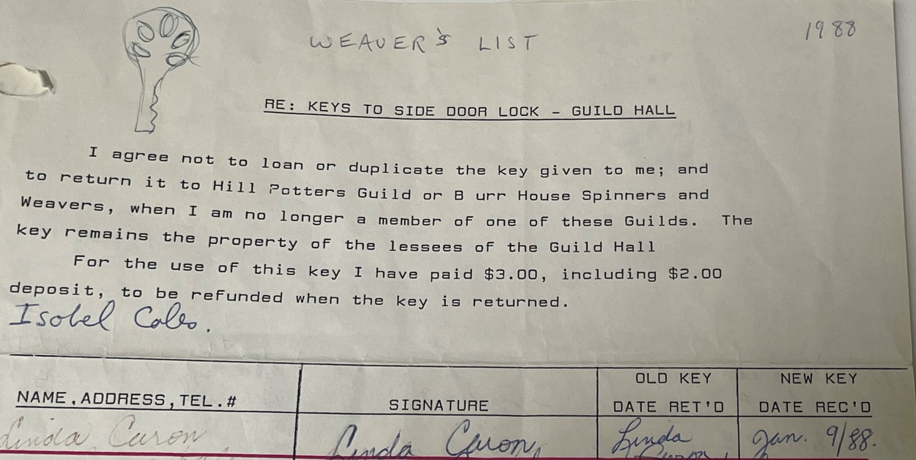

Look who’s weaving ...
